Project Work
of
Computer
Submitted to
Hari Kafle Sir
Department of Computer
Submitted by
Sambhav Rawat
Class: 12 ‘M’
Roll. No.: 32

Acknowledgement
I wish to express my profound appreciation to Mr. Hari Kafle for his invaluable guidance and support throughout the conceptualization and execution of this project on "Javascript" The opportunity to independently undertake this research was highly beneficial, and his expert insights were instrumental in shaping the final work.
-Sambhav Rawat

Materials Required
- Computer
- Textbook
- Reference Notes

Table of Contents
2
Acknowledgement 2
Materials Required 3
1. What is JavaScript? 5
2. JavaScript Questions 5
2.1. Write a JS function to convert ˚C to F 5
2.2. Write a JS function to calculate SI (Simple Interest). 6
2.3. Write a JS function to check even/odd. 7
2.4. Write a JS function to find largest among 3 numbers. 8
2.5. Write a JS function to calculate factorial. 9
2.6. Write a JS function to check palindrome (string). 10
2.7. Write a JS function to reverse a string. 11
2.8. Write a JS function to calculate total vowel in a string. 12
2.9. Write a JS function to validate email address format (check '@' and '.'). 13
2.10. Write a JS function to find fibonacci of first n numbers. 15

What is JavaScript?
JavaScript is a high-level, interpreted programming language that is one of the core technologies of the World Wide Web. Originally developed by Brendan Eich in 1995, it has evolved from a simple scripting tool for browsers into a versatile, powerful language used for full-stack development.

JavaScript Questions - 1

Write a JS function to convert ˚C to F
<!DOCTYPE html>
<html lang="en">
<head>
<meta charset="UTF-8">
<meta name="viewport" content="width=device-width, initial-scale=1.0">
<title>Document</title>
<link rel="stylesheet" href="style.css">
</head>
<body>
<div class="container">
<div class="Cel">
Cel: <input type="number" name="celcius" id="celcius-input" onchange="toFar(value)">
</div>
<div class="Far">
Far: <input type="number" name="farenheit" id="farenheit-input" onchange="toCel(value)">
</div>
</div>
<script src="script.js"></script>
</body>
</html>

function toCel(val) {
let cel = (val -32) * 5/9
document.getElementById("celcius-input").value = cel
}

function toFar(val) {
let far = (val * 9/5) + 32
document.getElementById("farenheit-input").value = far
}
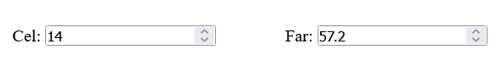

Write a JS function to calculate SI (Simple Interest).
<!DOCTYPE html>
<html lang="en">
<head>
<meta charset="UTF-8">
<meta name="viewport" content="width=device-width, initial-scale=1.0">
<title>Document</title>
<link rel="stylesheet" href="style.css">
</head>
<body>
<h3>SI calculator</h3>
<div>Enter principal: <input type="number" name="principal" id="principal" min="0"></div>
<div>Enter Rate: <input type="number" name="Rate" id="rate" min="0"></div>
<div>Enter Time: <input type="number" name="Time" id="time" min="0"></div>
<button style="margin-top: 10px;" onclick="calculateSI()">Calculate simple Intrest</button>
<p id="result"></p>
<script src="script.js"></script>
</body>
</html>

function calculateSI(){
p = document.getElementById("principal").value
t = document.getElementById("time").value
r = document.getElementById("rate").value
si = (p*t*r)/100
document.getElementById("result").innerText = "The SI is " + si
}

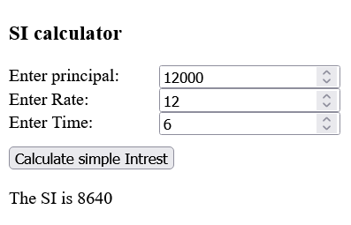

Write a JS function to check even/odd.
<!DOCTYPE html>
<html lang="en">
<head>
<meta charset="UTF-8">
<meta name="viewport" content="width=device-width, initial-scale=1.0">
<title>Document</title>
</head>
<body>
Enter a Number: <input type="number" name="number" id="number" onchange="check(value)">
<p id="result"></p>
<script src="script.js"></script>
</body>
</html>

function check(val) {
res = document.getElementById("result")
if(val % 2 == 0){
res.innerText = "The number is even"
}
else{
res.innerText = "The number is odd"
}
}
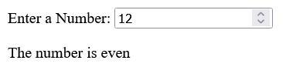

Write a JS function to find largest among 3 numbers.
<!DOCTYPE html>
<html lang="en">
<head>
<meta charset="UTF-8">
<meta name="viewport" content="width=device-width, initial-scale=1.0">
<title>Document</title>
<link rel="stylesheet" href="style.css">
</head>
<body>
<h3>largest Number</h3>
<div>First Number: <input type="number" name="1st" id="1st" onchange="check()"></div>
<div>Second Number: <input type="number" name="2nd" id="2nd" onchange="check()"></div>
<div>Third Number: <input type="number" name="3rd" id="3rd" onchange="check()"></div>
<p id="result"></p>
<script src="script.js"></script>
</body>
</html>

inputs = document.getElementsByTagName("input")
res = document.getElementById("result")

const check = () => {
num1 = inputs[0].value
num2 = inputs[1].value
num3 = inputs[2].value
let lar
if (num1 > num2 && num1 > num3) {
lar = num1
}
else if (num2 > num1 && num2 > num3) {
lar = num2
}
else {
lar = num3
}
res.innerText = lar + " is the largest number"
}

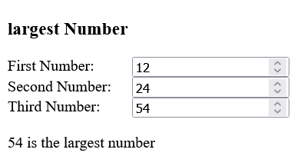
Write a JS function to calculate factorial.
<!DOCTYPE html>
<html lang="en">
<head>
<meta charset="UTF-8">
<meta name="viewport" content="width=device-width, initial-scale=1.0">
<title>Document</title>
<link rel="stylesheet" href="style.css">
</head>
<body>
<h3>Factorial Calculator</h3>
<div>Enter a number: <input type="number" onchange="check(value)"></div>
<p id="result"></p>
<script src="script.js"></script>
</body>
</html>

res = document.getElementById("result")
function check(val) {
final = 1
for (i = 1; i <= val; i++) {
final *= i
}
res.innerText = "The factorial is " + final
}

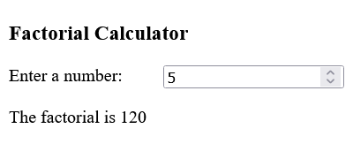

Write a JS function to check palindrome (string).
<!DOCTYPE html>
<html lang="en">
<head>
<meta charset="UTF-8">
<meta name="viewport" content="width=device-width, initial-scale=1.0">
<title>Document</title>
<link rel="stylesheet" href="style.css">
</head>
<body>
<h3>Palindrome Checker</h3>
<div>Enter a Word: <input type="text" onchange="check(value)"></div>
<p id="result"></p>
<script src="script.js"></script>
</body>
</html>

res = document.getElementById("result")
function check(val) {
console.log(val)
final = val.split('').reverse().join('')
if (val == final) {
res.innerText = "The String is palindrome"
}
else {
res.innerText = "The String is not plaindrome"
}
}
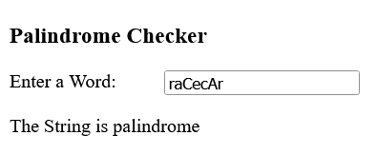

Write a JS function to reverse a string.
<!DOCTYPE html>
<html lang="en">
<head>
<meta charset="UTF-8">
<meta name="viewport" content="width=device-width, initial-scale=1.0">
<title>Document</title>
<link rel="stylesheet" href="style.css">
</head>
<body>
<h3>String Reverse</h3>
<div>Enter a Word: <input type="text" onchange="check(value)"></div>
<p id="result"></p>
<script src="script.js"></script>
</body>
</html>

res = document.getElementById("result")
function check(val) {
console.log(val)
final = val.split('').reverse().join('')
res.innerText = "Reverse String is " + final
}

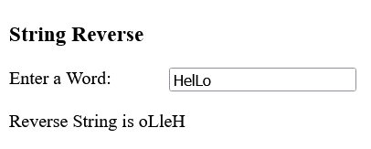

Write a JS function to calculate total vowel in a string.
<!DOCTYPE html>
<html lang="en">
<head>
<meta charset="UTF-8">
<meta name="viewport" content="width=device-width, initial-scale=1.0">
<title>Document</title>
<link rel="stylesheet" href="style.css">
</head>
<body>
<h3>Vowel Counter</h3>
<div>Enter a Word: <input type="text" id="inp"></div>
<button onclick="check()">Check</button>
<p id="result"></p>
<script src="script.js"></script>
</body>
</html>

res = document.getElementById("result")
elem = document.getElementById("inp")
function check() {
let val = elem.value
val = val.toLowerCase();
let c = 0
for (let letter of val) {
switch (letter) {
case "a":
c++
break;
case "e":
c++
break;
case "i":
c++
break;
case "o":
c++
break;
case "u":
c++
break;
}
}
res.innerText = "Number of vowels is " + c }
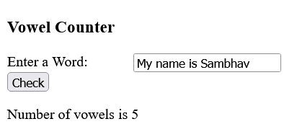

Write a JS function to validate email address format (check '@' and '.').
<!DOCTYPE html>
<html lang="en">
<head>
<meta charset="UTF-8">
<meta name="viewport" content="width=device-width, initial-scale=1.0">
<title>Document</title>
<link rel="stylesheet" href="style.css">
</head>
<body>
<h3>Email Validator</h3>
<div>Enter an Email: <input type="text" id="mail"></div>
<button onclick="check()">Validate</button>
<p id="result"></p>
<script src="script.js"></script>
</body>
</html>

res = document.getElementById("result")
function check() {
elem = document.getElementById("mail").value
let indexesOfdot = indexesOf(elem, ".")
let indexesOfAtr = indexesOf(elem, "@")

if (indexesOfAtr.length == 0 || indexesOfdot.length == 0) {
res.innerText = "Either '.' or '@' is missing"
return
}
let indexOfLastDot = indexesOfdot[indexesOfdot.length - 1], indexOfLastAtr = indexesOfAtr[indexesOfAtr.length - 1]
if (indexOfLastDot < indexOfLastAtr) {
res.innerText = "Invalid Mail"
return
}
if (indexOfLastDot == elem.length - 1) {
res.innerText = "Invalid Mail"
return
}
if ((indexOfLastAtr + 1) == indexOfLastDot) {
res.innerText = "Invalid Mail"
return
}
res.innerText = "Valid Mail"
}

function indexesOf(arr, val) {
let indexes = [], i = -1
while ((i = arr.indexOf(val, i + 1)) != -1) {
indexes.push(i)
}
return indexes
}

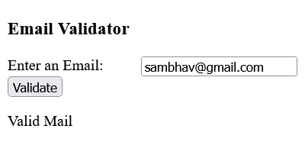
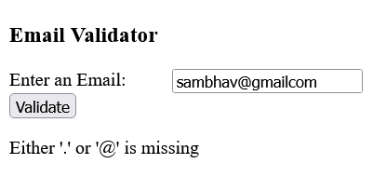

Write a JS function to find fibonacci of first n numbers.
<!DOCTYPE html>
<html lang="en">
<head>
<meta charset="UTF-8">
<meta name="viewport" content="width=device-width, initial-scale=1.0">
<title>Document</title>
<link rel="stylesheet" href="style.css">
</head>
<body>
<h3>Fibonacci Generator</h3>
<div>Enter a Number:
<input type="number" onchange="check(value)">
</div>
<p id="result"></p>
<script src="script.js"></script>
</body>
</html>

res = document.getElementById("result")
function check(val) {
let final = "";
a = 0; b = 1; c = a + b;
for (let i = 0; i < val; i++) {
final += a + " ";
c = a + b;
a = b
b = c
}
res.innerText = final
}

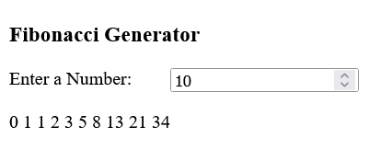

JavaScript Project – Calculator
<!DOCTYPE html>
<html lang="en">
<head>
<meta charset="UTF-8">
<meta name="viewport" content="width=device-width, initial-scale=1.0">
<title>Document</title>
<link rel="stylesheet" href="style.css">
</head>
<body>
<div class="container">
<h1>Calculator</h1>
<div class="calculator">
<div class="screen">
<p id="screen"></p>
</div>
<div class="keypad">
<div class="number">
<button value="9">9</button>
<button value="8">8</button>
<button value="7">7</button>
<button value="6">6</button>
<button value="5">5</button>
<button value="4">4</button>
<button value="3">3</button>
<button value="2">2</button>
<button value="1">1</button>
</div>
<div class="symbol symbol-1">
<button value="+">+</button>
<button value="-">-</button>
<button value="*">*</button>
</div>
<div class="symbol symbol-2">
<button value=".">.</button>
<button value="0" class="black">0</button>
<button value="=">=</button>
<button value="/">/</button>
</div>
<div class="symbol symbol-3">
<button value="del">del</button>
<button value="c">c</button>
</div>
</div>
</div>
<p id="result"></p>
<script src="script.js"></script>
</div>
</body>
</html>

let str = ''
const btns = document.querySelectorAll("button")
console.log(btns)

for (const btn of btns) {
btn.addEventListener("click", (e) => handleEvent(e.target.innerText))
}

function handleEvent(e) {
console.log(e)
switch (e) {
case "=":
str = eval(str)
break;

case "del":
str = str.slice(0, -1)
break;

case "c":
str = ''
break;

default:
str += e
break;
}
display(str)
}

function display(val) {
let elem = document.getElementById("screen")
elem.innerText = val
}

